Virendra Sharma

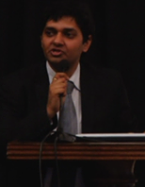

Co-Founder & COO @KUMPEL

TEDx Speaker

**Archie singh**

First Indian to win 2nd Runner Up @Miss International Trans



**Parth Vijayvergiya**

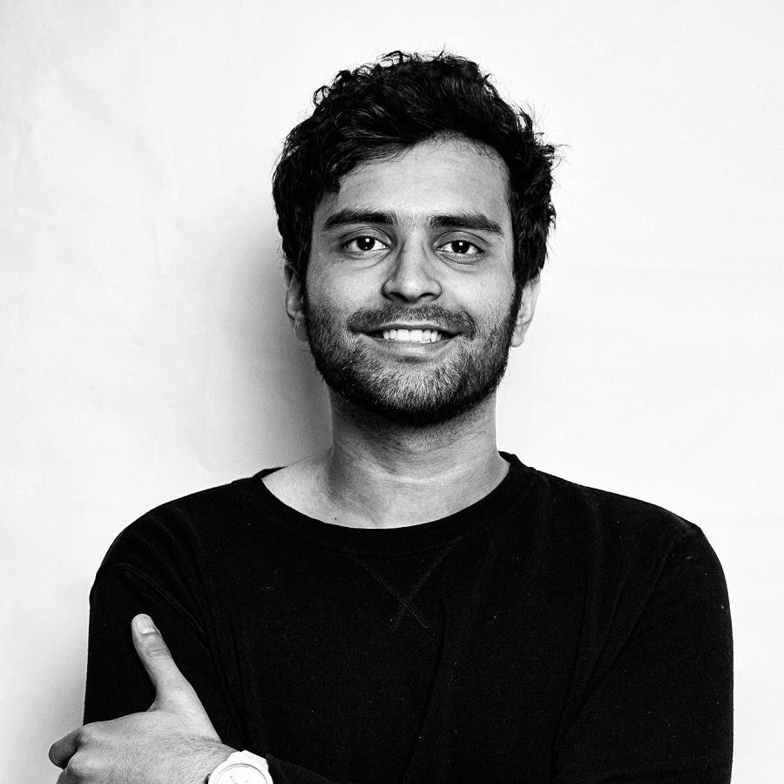

Education YouTuber

100K+ Subscribers